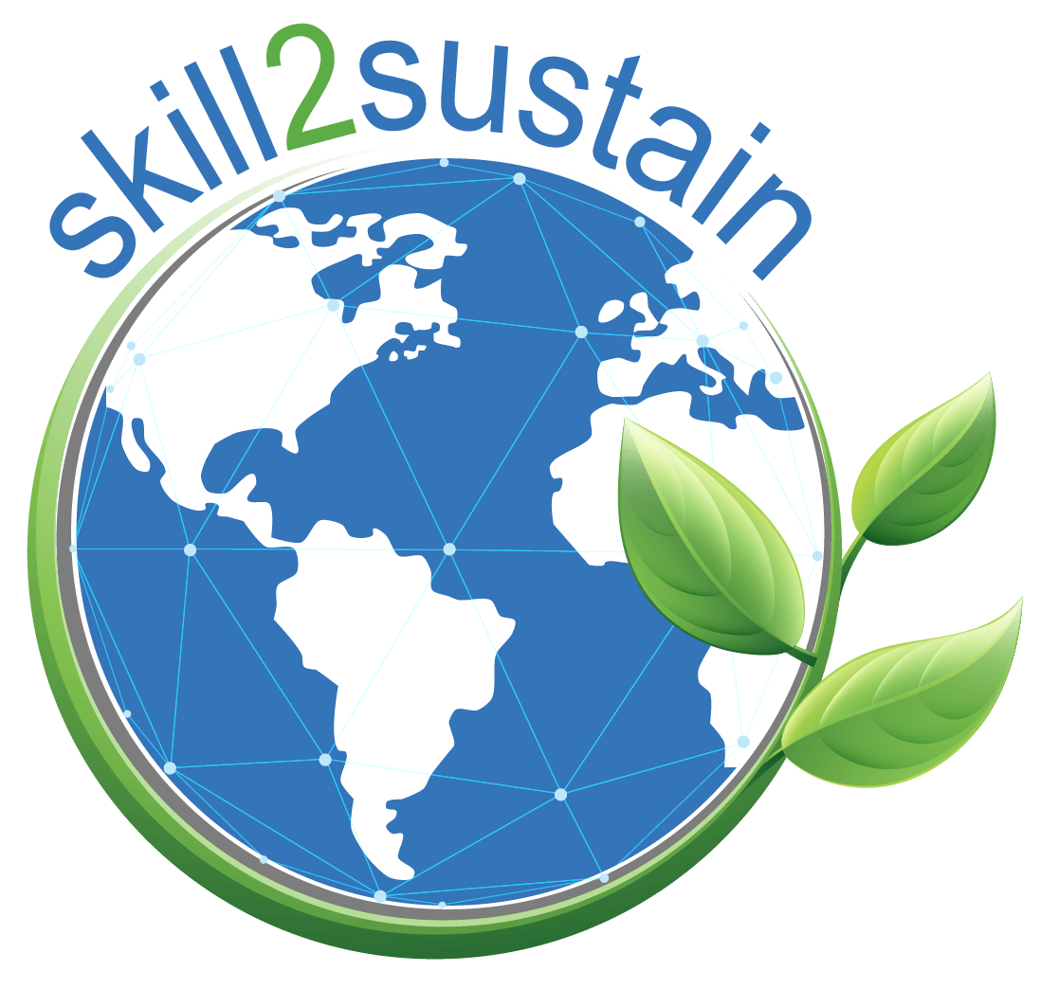
Project title:  Boosting digital and green skills for a resilient and sustainable Western Balkan society  Acronym:  SKILL2SUSTAIN  Program:  ERASMUS-EDU-2024-CBHE-STRAND-2 (Project no. 101178204)  Duration:  36 months (2025-2028)  Abstract:  Boosting digital and green skills for a resilient and sustainable Western Balkan Boosting digital and green skills for a resilient and sustainable Western Balkan society – SKILL2SUSTAIN is fully aligned with the objectives of the CBHE action, its activities, and the specificities of Strand II. The urgent need for the Western Balkans to accelerate the twin green and digital transition has been recognized through analyses conducted in the target countries of Region 1. The broader aim of the project is to mainstream a holistic approach to digitalization and the green transition, while its specific objectives are in line with the EU Green Deal, the Digital Education Action Plan 2021–2027, and the Council Recommendation on learning for the green transition and sustainable development. The project supports higher education systems in creating green and digital societal ecosystems.  A Digital and Green Initiative for WBC Education in Academia will be developed and signed by all project partners. Over three years, 10 curricula will be modernized or newly developed and implemented across 5 WBC HEIs: 2 new BSc programs in Disaster Risk Management, 3 modernized BSc/MSc programs, and 5 new certified LLL programs. These will introduce innovative green topics such as circular economy, energy efficiency, renovation wave, climate change adaptation, sustainability, disaster resilience, and digital skills in Building Information Modeling (BIM) and Geographic Information Systems (GIS).  The modernization and development paths will be defined based on national and regional needs, supported by knowledge transfer from EU HEIs. Furthermore, 5 ICT-based interoperable Research and Education Centers will be established at WBC HEIs. Teaching methodologies will be enhanced through study visits, and blended learning materials will be offered in EN/ALB/MNG/BIH/SRB via an ICT collaboration platform and an open-access e-library.  Specific project objectives:  - SO1: Establish Research and Education Centres (RECs) for green and digital transition within each WBC HEIs.  - SO2: Raise awareness of staff and student community on the needs for green and digital skills within HEIs.  - SO3: Promote green transition and digitalization culture within WBC HEIs.  - SO4: Increase Synergies between academia and stakeholders for implementing joint initiatives for green transition and digitalization.  - SO5: Reinforce networking and collaboration between staff and student communities of WBC and EU about digitalization and green transition actions.  Partners:  - University of Novi Sad (Serbia) - COORDINATOR  - University of Montenegro (Montenegro)  - University of Tirana (Albania)  - Polytechnic University of Tirana (Albania)  - University of Banja Luka (Bosnia and Herzegovina)  - University College “CEPS-Center for Business Studies” Kiseljak (Bosnia and Herzegovina)  - University of Ljubljana (Slovenia)  - University of Zagreb (Croatia)  - Ss. Cyril and Methodius University in Skopje-UKIM (N. Macedonia)  - Građevinarstvo – nauka i praksa – Podgorica (Montenegro)  - Chamber of Engineers of Montenegro (Montenegro)  - Environmental and Territorial Management Institute (Albania)  - Chamber of Commerce and Industry of Banja Luka Region (Bosnia and Herzegovina)  - Chamber of Commerce of the Federation of Bosnia and Herzegovina, BiH  Role in the project:  Partner / Beneficiary (BEN)  Project Website:  https://skill2sustain.uns.ac.rs/  Posts related to this project:  - LinkedIN: https://www.linkedin.com/company/skill2sustain/?viewAsMember=true | IMPORTANT LINKS  Project Website  https://skill2sustain.uns.ac.rs  Project social networks:  LinkedIN: https://www.linkedin.com/company/skill2sustain/?viewAsMember=true

“Funded by the European Union. Views and opinions expressed are however those of the author(s) only and do not necessarily reflect those of the European Union or [name of the granting authority]. Neither the European Union nor the granting authority can be held responsible for them.”

